
Computer Networks Lab_241L
UW-24-CS-BS-101
Registration NO:
Muhammad Talha_CS.3ndB
Lab Task # 07
UNIVERSITY OF WAH(UOW)

DEPARTMENT OF COMPUTER
SCIENCE

COURSE:

SUBMITTED TO:

Mr. Hassan Shafaqat
SUBMITTED BY:

Task
Adding routes on screen
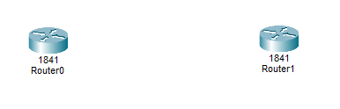
Adding switches and PC’s on screen
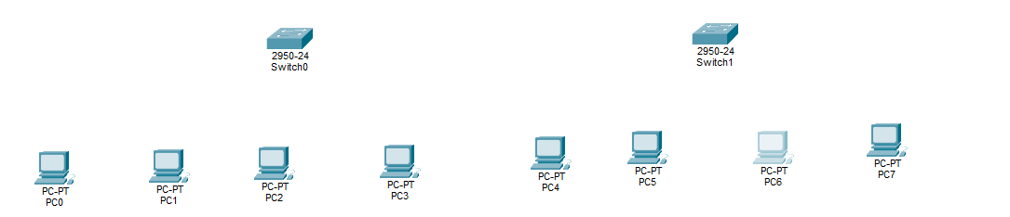
Arranging in order
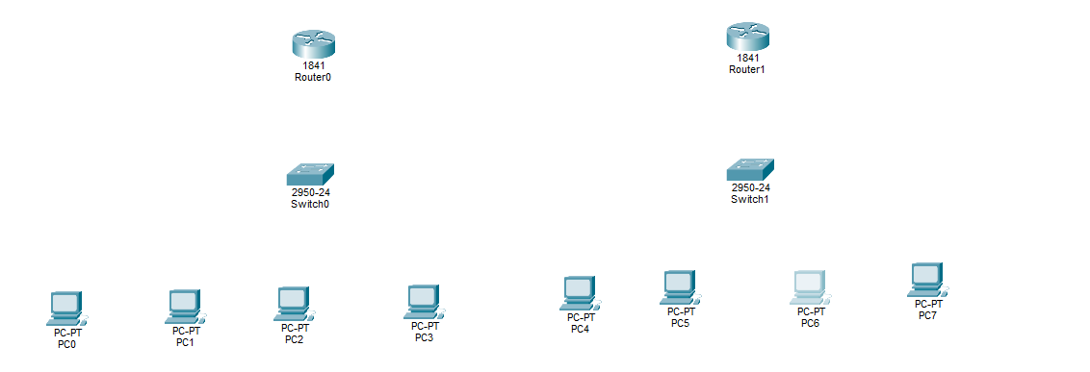
Connection two routers together
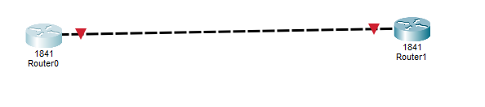
Connecting routers to switches
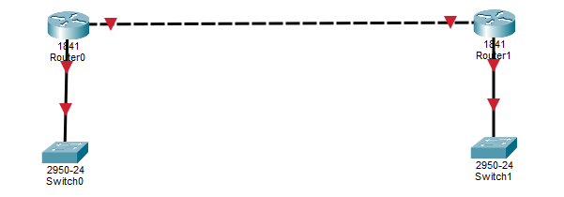

Connectiong to switches to PC’s
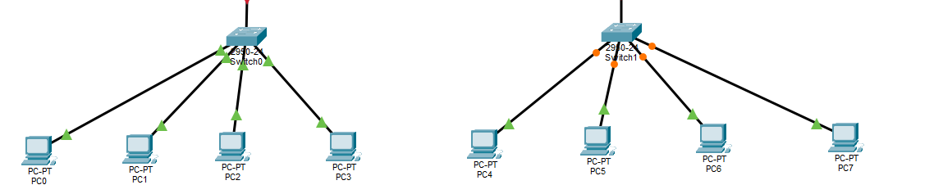
Giving address to routers
Route 1:
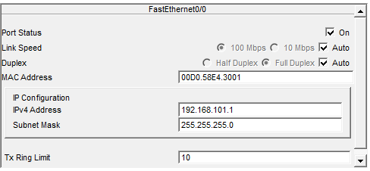
Route 2:
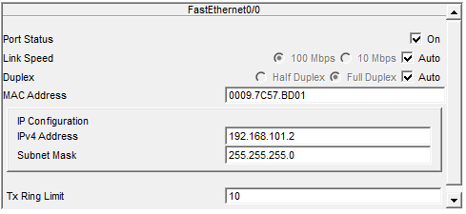

Now Giving Address to Switches Side 0/2:
Switch 1:
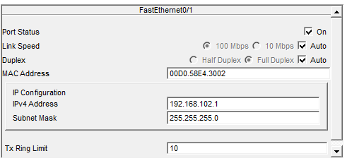
Switch 2:
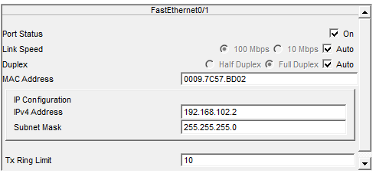
Now giving IP address and Gateways to all PCs
PC 1:
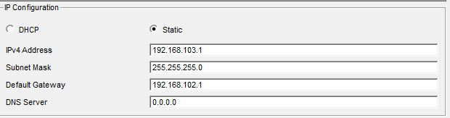
PC 2:
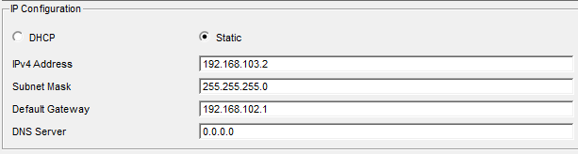
PC 3:
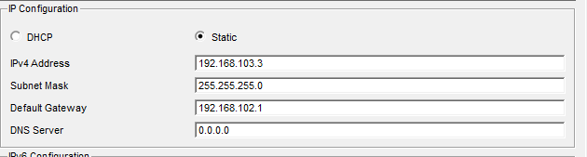
PC 4:
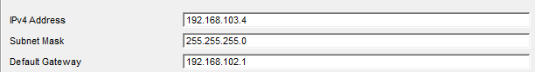

PC 5:
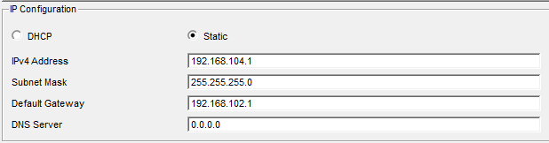
PC 6:
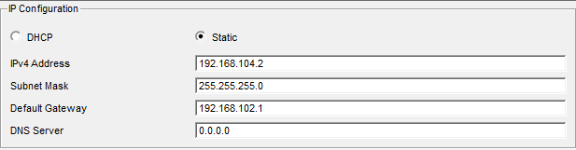
PC 7:
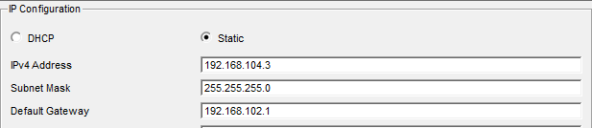
PC 8:
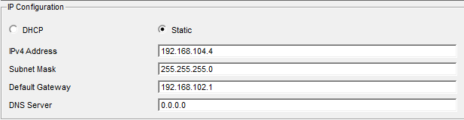

Adding comments to PC’s:
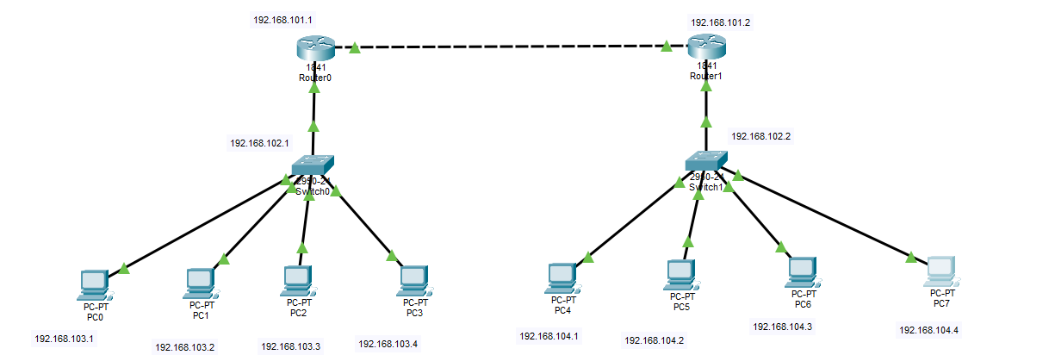
Apply static Route on Router 1:
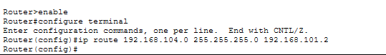
Apply static Route on Router 2:
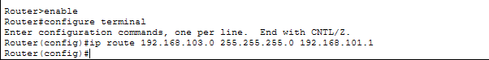
Messages sending:
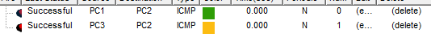
Message sending through ping commands:
PC 1:
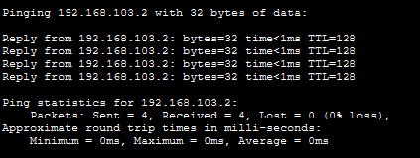
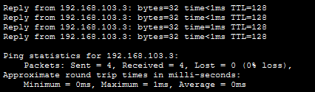

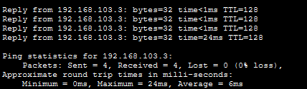
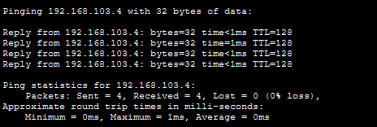




PC 2:









PC 3:









PC 4:









PC 5:









PC 6:









PC 7:










PC 8:










